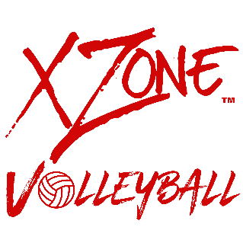
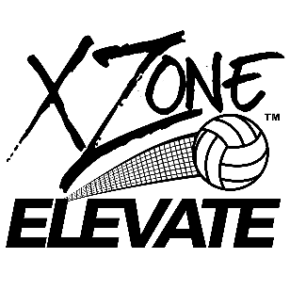

ATHLETE CODE OF BEHAVIOR
As an athlete, I…
- will participate in volleyball without the use of alcohol or any illegal substances including drugs and nicotine (vaping)
- will exercise self-control and use positive verbal and physical behavior (I took out aggression)
- will give true information concerning another individual’s involvement in or knowledge of an incident relevant to a violation of the rules
- will play by the rules of volleyball and abide by the USAV and AAU regulations and player conduct code
- will display fair play by treating all those involved in the match with dignity and respect
- will be mindful of others and treat those as I would like to be treated
- will work hard to improve performance and participate 100% to the best of my ability
- will maintain a positive image of myself; <- this is a weird rule erase plz
- will be attentive during practice and respect my coaches decisions, following their instruction during practices and tournaments

PARENT CODE OF BEHAVIOR As a parent, I:
- will be positive in attitude toward volleyball and emphasize the cooperative nature of the sport
- will encourage hard work and honest effort that will lead to improved performance and participation
- will encourage and respect the coaches, referees, and officials and their integrity (will encourage sounds weird)
- will encourage athletes to participate for their own enjoyment
- will be supportive of all attempts to remove verbal and physical abuse from organized volleyball activities, including language (maybe say this) Will not engage in disrespectful conduct during the match including profanity, obscene gestures, and negative remarks toward players, parents, or officials
- will meet the required administrative and programmatic rules if in some cases the athletes are not in the ability to do so-paperwork is in and signed with memberships active etc; (no idea what you mean) maybe say something else
- will stay away from the playing area during the match;
- will applaud fair play during matches whether a call is made against an xzone team or the opponent’s team and show support regardless of the end result of the match <- I was not sure what you were originally trying to say so idk if I said what you were saying
SPECTATOR CODE OF BEHAVIOR As a spectator, I:
- will respect the rights of others and treat the visiting team and their spectators courteously;
- will abide by all applicable federal, state, and local laws while attending any match;
- will cheer positively for my team as well as opposing teams rather than against them, using socially acceptable language; <- I wouldn’t say socially acceptable language people can take that very differently also don’t necessarily need to cheer for opponent maybe just say you will treat them with respect
- will respect the integrity and judgment of the coaches and officials without taunting or approaching them between games or at the end of the match
- will use only designated smoking areas that are clearly posted;
- will use litter receptacles to properly dispose of trash;
- will applaud good performances by both teams; <- I would take this out
- will use items to cheer with that are of a non-violent nature and follow USAV guidelines
- will discourage all forms of violent behavior

Consequences for not following the Code of Behaviors of XZone Volleyball Club
(Player, Parent, or Spectator Behaviors) :

- Verbal Warning
- Parent/Player Meeting with Coach and Coordinator (those behaviors with astericks ** beside them jump to this step immediately and can lead to dismissal after the meeting is held depending on outcome. <- I would leave this up to the coaches discretion // as in no need to use asterisks just have meeting and decide)
- Dismissal from team

Parents who continually display un-sportsmanship or negative attitudes during tournament play and promote players having a disrespecting attitude toward coaches and officials will be asked to leave the venue immediately. A meeting will be held to meet with the director, coach, and coordinators of XZone before the parent is allowed to observe other events.

I understand the behaviors expected during the season and agree to the consequences listed. (moved this below consequences)

Parent: ____________________________________________ Date: ______________

Player: ____________________________________________ Date: ______________

